Personal Income and Expense Tracker

Student Name: Bohdan Zvarych
Date: April 2026

Section A — Python Code

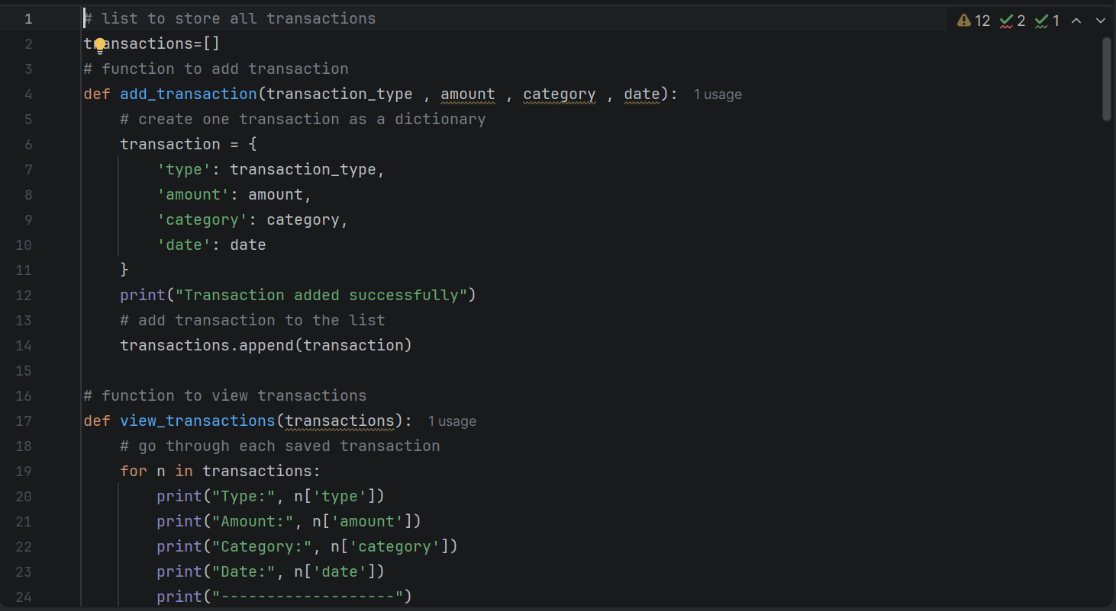
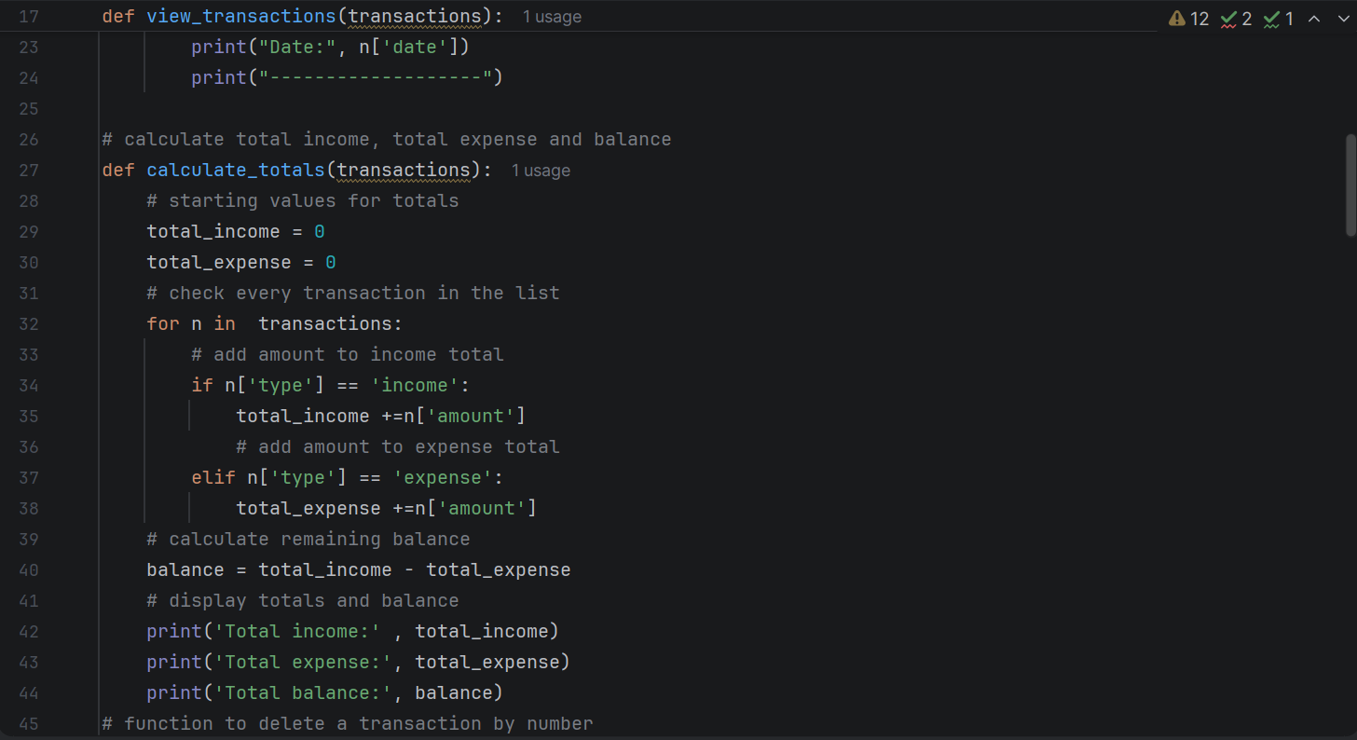
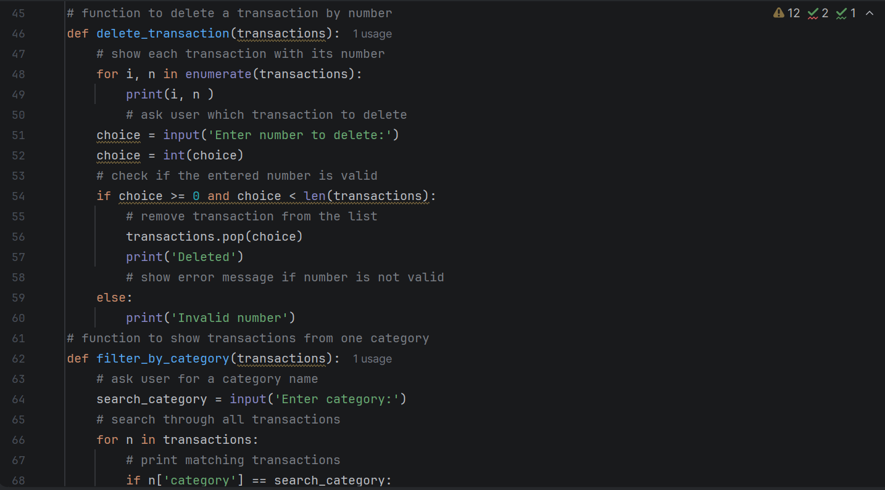
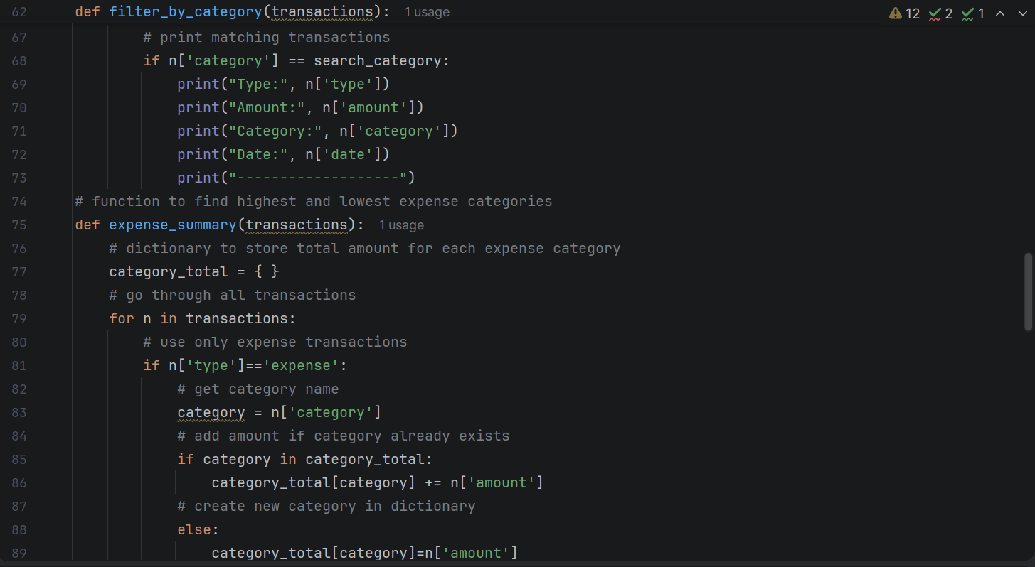
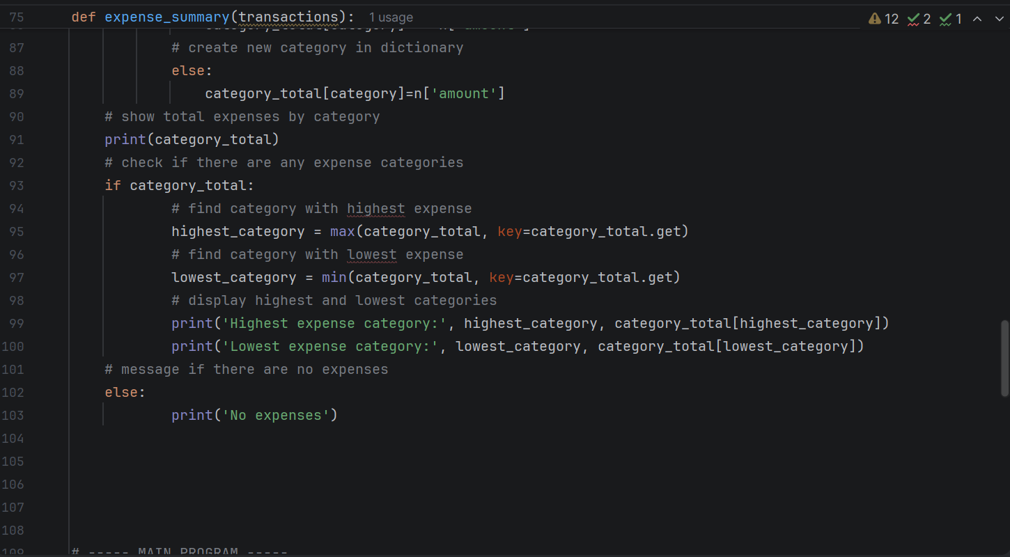
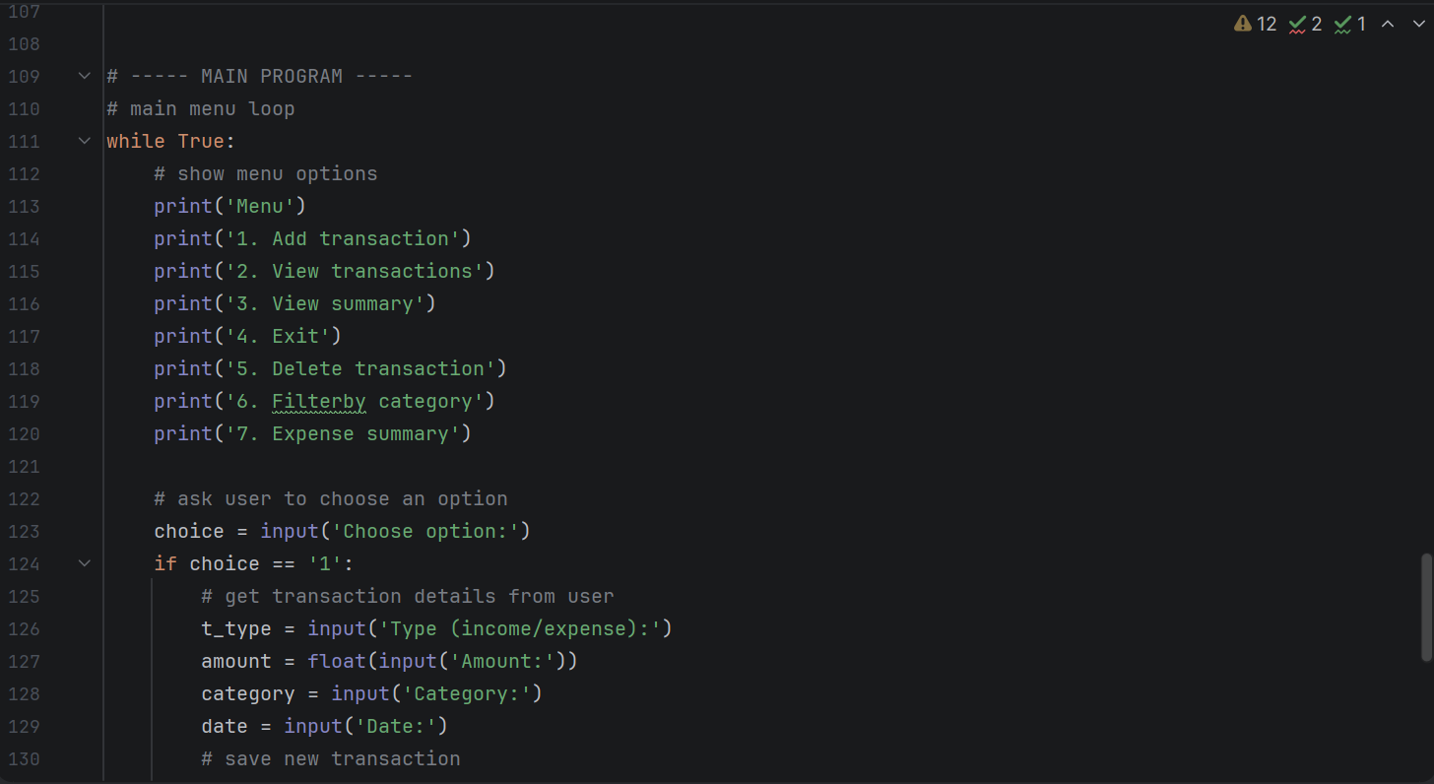
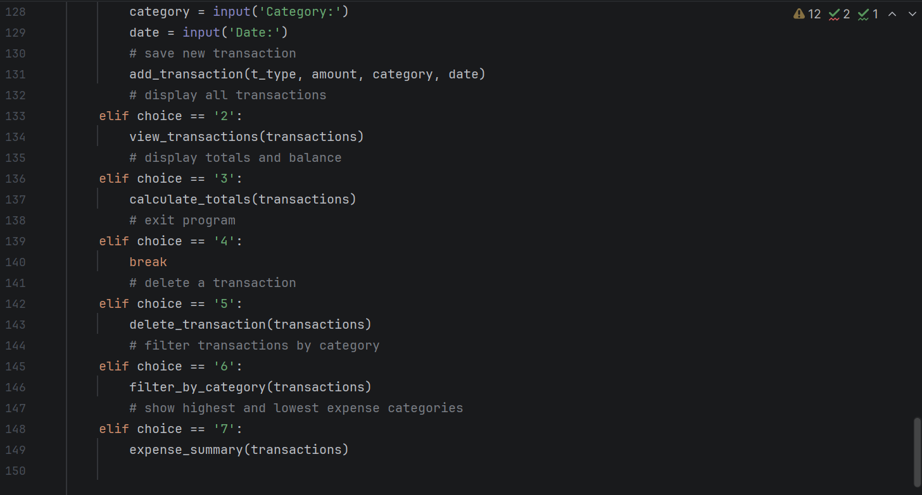
Section B — Description
This program was designed as a simple income and expense tracker using native Python only. I used a list to store all transactions, and each transaction is saved as a dictionary containing the type, amount, category, and date. This structure was chosen because it allows multiple pieces of information to be grouped together clearly and makes it easier to add, view, delete, and filter transactions.

The program uses a menu system with control flow so the user can choose different actions, such as adding a transaction, viewing all transactions, deleting an entry, or filtering by category. Separate functions were created for each main task to keep the code organised and easier to read.

For calculations, the program loops through the list of transactions and checks whether each item is income or expense. It then calculates total income, total expense, remaining balance, and identifies the highest and lowest expense categories.

Section C — Program Output
Screenshot 1 - Menu:
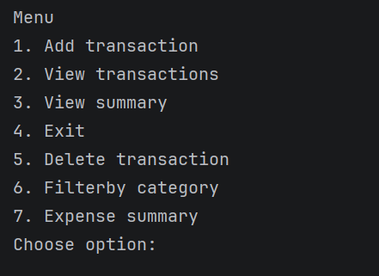

Screenshot 2 - Add Transaction:
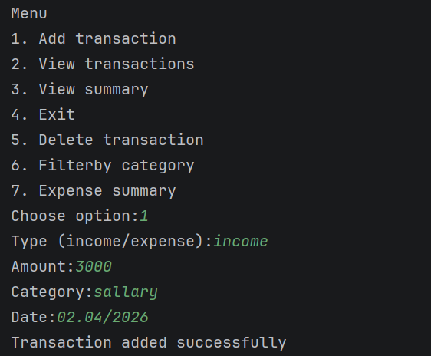

Screenshot 3 - Summary:
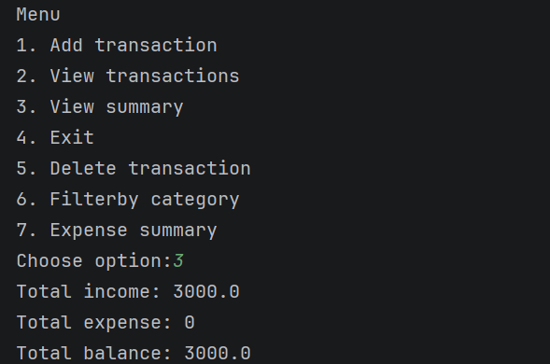 .

Screenshot 4 - View transactions:
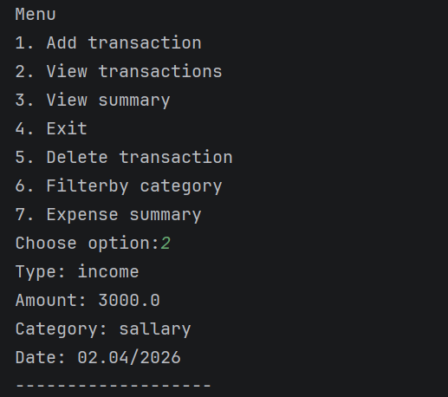

Screenshot 5 - Expense summary:
